
STANDARD DRAWING EXTRA LOW VOLTAGE INTEGRATION BLOCK DIAGRAM

27/03/19 BORDER CHANGED AND ISSUED FOR USE
24/01/18 ISSUED FOR USE
002
REV
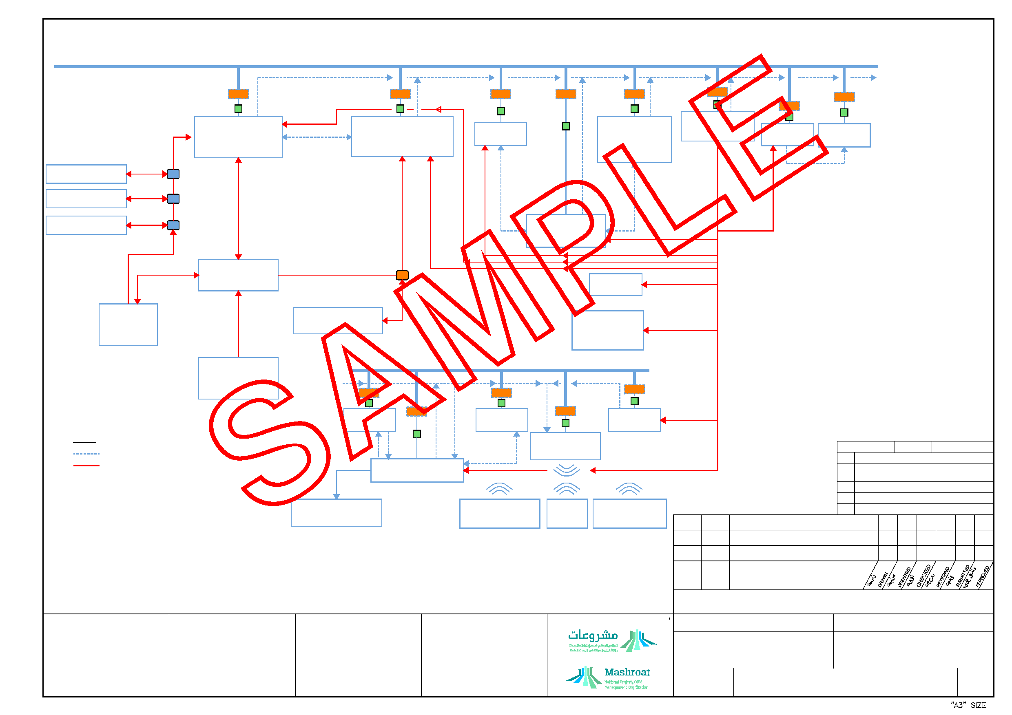
IT LAN-TCP/IP
ETHERNET
SWITCH/ROUTER (TYP.)
GATEWAY (AS REQ.)
EPMS TROUBLE ALARM TO
MAINTENANCE VIA WIRELESS NETWORK
BMS TROUBLE ALARM TO MAINTENANCE
GATEWAY AS REQ. (TYP)
SAC ALARM TO SECURITY
OPT2 TIME SYNC.
VIA LAN TCP/IP FOR
IP BASED SYSTEMS
SWITCHBOARDS
MCC, RMU, UPS
SWITCHGEARS
CONTROL/ MONITOR
CONTROL/ MONITOR
CONTROL/ MONITOR
RTU (TYP.)
ELECTRICAL POWER
MANAGEMENT
SYSTEM
MONITORING & CONTROL
(REMOTE SWITCHING, POWER,
CONSUMPTION, STATUS ETC.)
MONITORING OF STATUS
BUILDING MANAGEMENT
SYSTEM (Graphical User
Interface)
IP CCTV
MONITORING AND CONTROL
SECURITY AND ACCESS CONTROL
UTP CABLE (TYP.)
SAC A ARM TO SECURITY
DOOR
INTERCOM AND ACCESS SYSTEM
MONITORING AND CONTROL
R5 85 (Ms/TP) VIA
MODBUS (TYP)
MASTER CLOCK
SYSTEM PAVA IPTV
OPTION 1 TIME SYNCHRONIZATION
FOR NON IP SYSTEMS
SOFTWARE INTEGRATION THRU LAN VIA TCP/IP OR VIA COAXIAL CABLE THRU SET TOP BOXES FOR NON IP TV
Level - 3 - E, External
Electronic documents once printed, are uncontrolled and may become out-dated. Refer to ECMS for current revision
LEGEND:
SOFTWARE INTEGRATION THRU MODBUS VIA LAN TCP/IP
HARDWARE ANALOGUE OR DIGITAL INTEGRATION
DDC DIRECT DIGITAL CONTROLLER
RTU REMOTE TERMINAL UNIT
OPTION 1 CONTROL & MONITOR
AUTOMATIC
TRANSFER
SWITCH
OPTION 2 - CONTROL
& MONITOR
EMERGENCY
POWER SYSTEM
GENERATOR SET
PARALLELING SWITCHGEAR
MONITORING (KVA,
VOLTAGE,PHASE,
ANGLE & FREQUENCY)
LIGHTING CONTROL PANELS
PATIENT ROOM LIGHTING SYSTEM
OPTION 1 - MONITORING OF
CONTINUATION
STATUS
2 WAY
COMM NICATION
CA LING
VOIP
NURSE CALL SYSTEM
MONITORING & CONTROL
DDC (TYP.)
PANIC ALARM TO S A &
PATIENT MANAGEMENT TO MS
TIME MANAGEMENT
FROM RTLS
IT LAN TCP/IP
MOBILE PHONES (MAINT.,PATIENT)
PATIENT FILE MANAGEMENT
ADT
WIRELESS NETWORK
RTLS
PATIENT WIRELESS NOTIFICATION
PARKING
MANAGEMENT
SYSTEM
MOBILE PHONE (SECURITY)
FDAS
Q-MATIC
R5485 (Ms/TP) VIA
R5485 (Ms/TP) VIA
MODBUS (TYP)
MODBUS (TYP)
000
DA/SY CHAIN FIELD CONNECTION
ENGINEER
REVIEW STATUS
A - REVIEWED; WORK MAY PROCEED
B - REVIEWED WITH COMMENTS; REVISE & RESUBMIT;
C - OBJECTION - REVISE & RESUBMIT; WORK MAY
D - REJECTED
E - REVIEW NOT REQUIRED; WORK MAY PROCEED
WORK MAY PROCEED SUBJECT TO INCORPORATION OF COMMENTS
NOT PROCEED
DATE:
NAME:
REV. No
DATE
REASON FOR ISSUE
DRAWING STATUS
ISSUED FOR USE
KINGDOM OF SAUDI ARABIA راممقكم راراقم رسمللم
PROJECT REFERENCE -
PROJECT TITLE 1
FACILITY No.
XXX
ARABIC TITLE
PROJECT TITLE 2
PROJECT TITLE 3
ARABIC TITLE
SCALE
CONTRACT No.
DRAWING No.
X
SHEET 1 OF 1
NTS
EPM-KEE-13-000001
002

